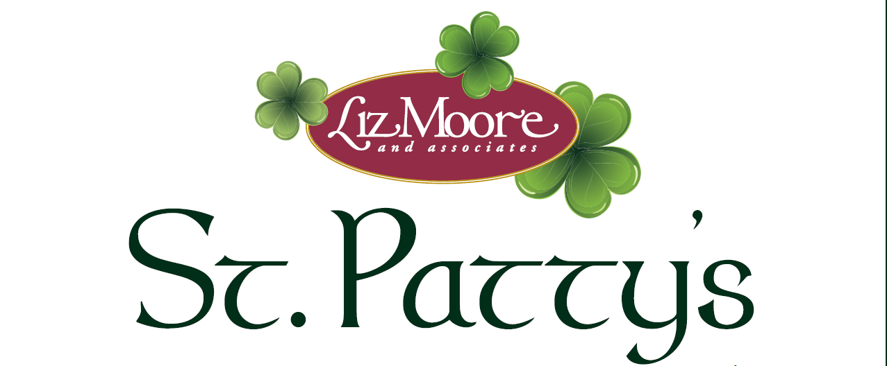

Open House Extravaganza
You are cordially invited to a special
preview of this spectacular listing!

288 Walt Whitman Avenue Saturday, March 14
Newport News, VA 23606 1:00PM – 3:00PM

Alyssa Godwin, REALTOR®
757-329-6161
www.alyssagodwin.com

